**Encoding the serial number (SN: YYMMDD-xx-xxxxxxxx-xxx-xxxxx) of microIOC**

Serial number is formed on the same principle:

* First six digits represent production date code (YYMMDD)
* Following 13 digits represent enclosure version including power supply types and type of SBC and add on cards.
* Last five digits are incremental serial number (some time ago this was ip number).

**microIOCs produced before August 2012**

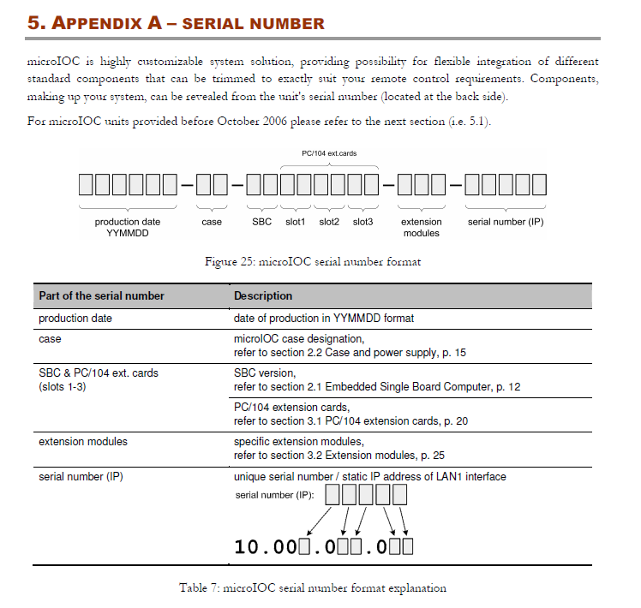

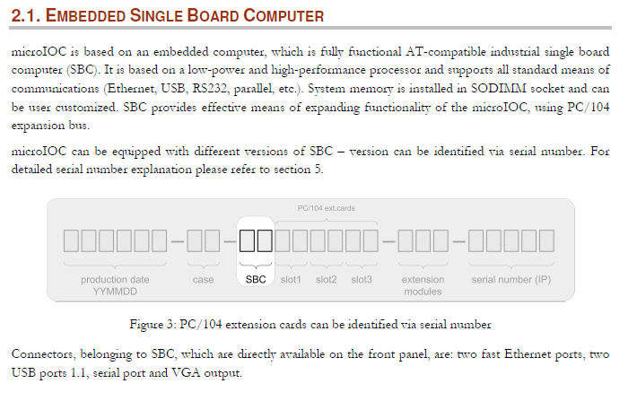

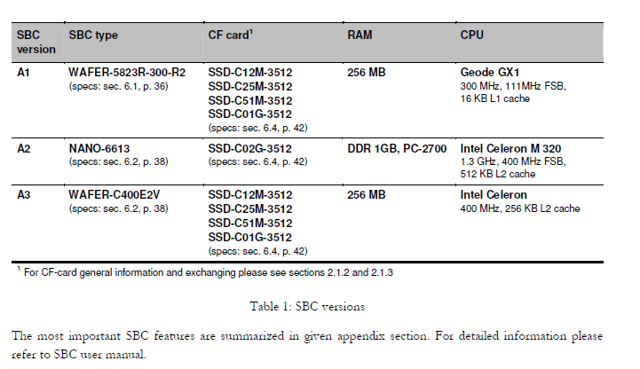

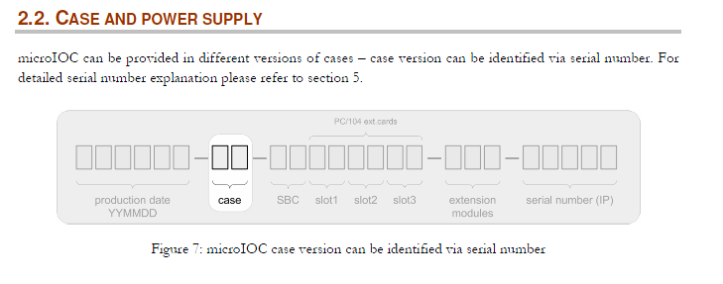

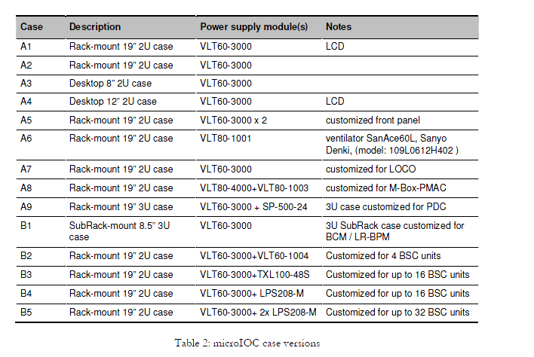

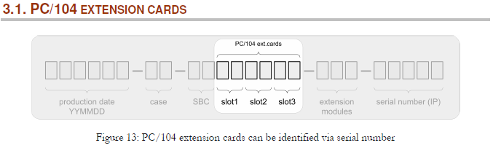

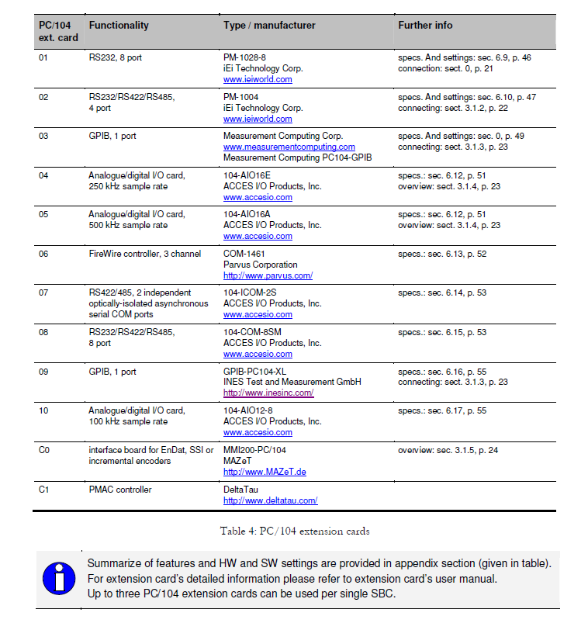

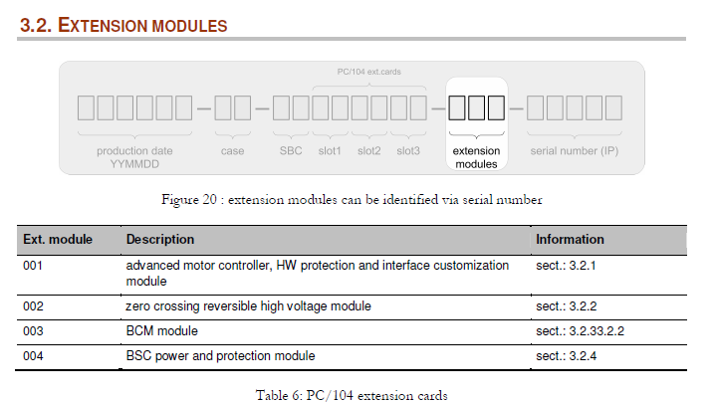

**microIOCs produced from August 2012 on**





